NARTS
UNIFIED PLANNING WORK PROGRAM
FISCAL YEAR 2017
This Fiscal Year (FY) 2017 Unified Planning Work Program (UPWP) outlines the planning activities of the Northwest Arkansas Regional Planning Commission (NWARPC) serving as the Northwest Arkansas Regional Transportation Study (NARTS) from July 1, 2016 through June 30, 2017.

THE NORTHWEST ARKANSAS REGIONAL PLANNING COMMISSION:

AVOCA BELLA VISTA
BENTON COUNTY BENTONVILLE
BETHEL HEIGHTS CAVE SPRINGS
CENTERTON DECATUR
ELKINS ELM SPRINGS
FARMINGTON FAYETTEVILLE
GARFIELD GATEWAY
GENTRY GOSHEN
GRAVETTE GREENLAND
HIGHFILL JOHNSON
LINCOLN LITTLE FLOCK
LOWELL McDONALD COUNTY, MO
PEA RIDGE PRAIRIE GROVE
PINEVILLE, MO ROGERS
SILOAM SPRINGS SPRINGDALE
SPRINGTOWN SULPHUR SPRINGS
TONTITOWN WASHINGTON COUNTY
WEST FORK UNIVERSITY OF ARKANSAS
RAZORBACK TRANSIT OZARK REGIONAL TRANSIT, INC
ARKANSAS STATE HIGHWAY AND TRANSPORTATION DEPARTMENT
MISSOURI DEPARTMENT OF TRANSPORTATION

IN COOPERATION WITH:
U.S. DEPARTMENT OF TRANSPORTATION
FEDERAL HIGHWAY ADMINISTRATION
FEDERAL TRANSIT ADMINISTRATION

This document was funded in part through grant(s) from the Federal Highway Administration, the Federal Transit Administration, and/or the United States Department of Transportation. The views and opinions of the NWARPC expressed herein do not necessarily state or reflect those of the United States Department of Transportation.

NWARPC Notice of Nondiscrimination
The Northwest Arkansas Regional Planning Commission complies with all civil rights provisions of federal statues and related authorities that prohibit discrimination in programs and activities receiving federal financial assistance. Therefore, the NWARPC does not discriminate on the basis of race, sex, color, age, national origin, religion or disability, in the admission, access to and treatment in NWARPC’s programs and activities, as well as the NWARPC’s hiring or employment practices. Complaints of alleged discrimination and inquiries regarding the NWARPC’s nondiscrimination policies may be directed to Celia Scott-Silkwood, AICP, Regional Planner – EEO/DBE (ADA/504/Title VI Coordinator), 1311 Clayton, Springdale, AR 72762, (479-751-7125, (Voice/TTY 7-1-1 or 1-800-285-1131) or the following email address: cscott-silkwood@nwarpc.org. This notice is available from the ADA/504/Title VI Coordinator in large print, on audiotape and in Braille. If information is needed in another language, contact Celia Scott-Silkwood. Se necesita informacion en otro idioma, comuniquese Celia Scott-Silkwood, cscott-silkwood@nwarpc.org.
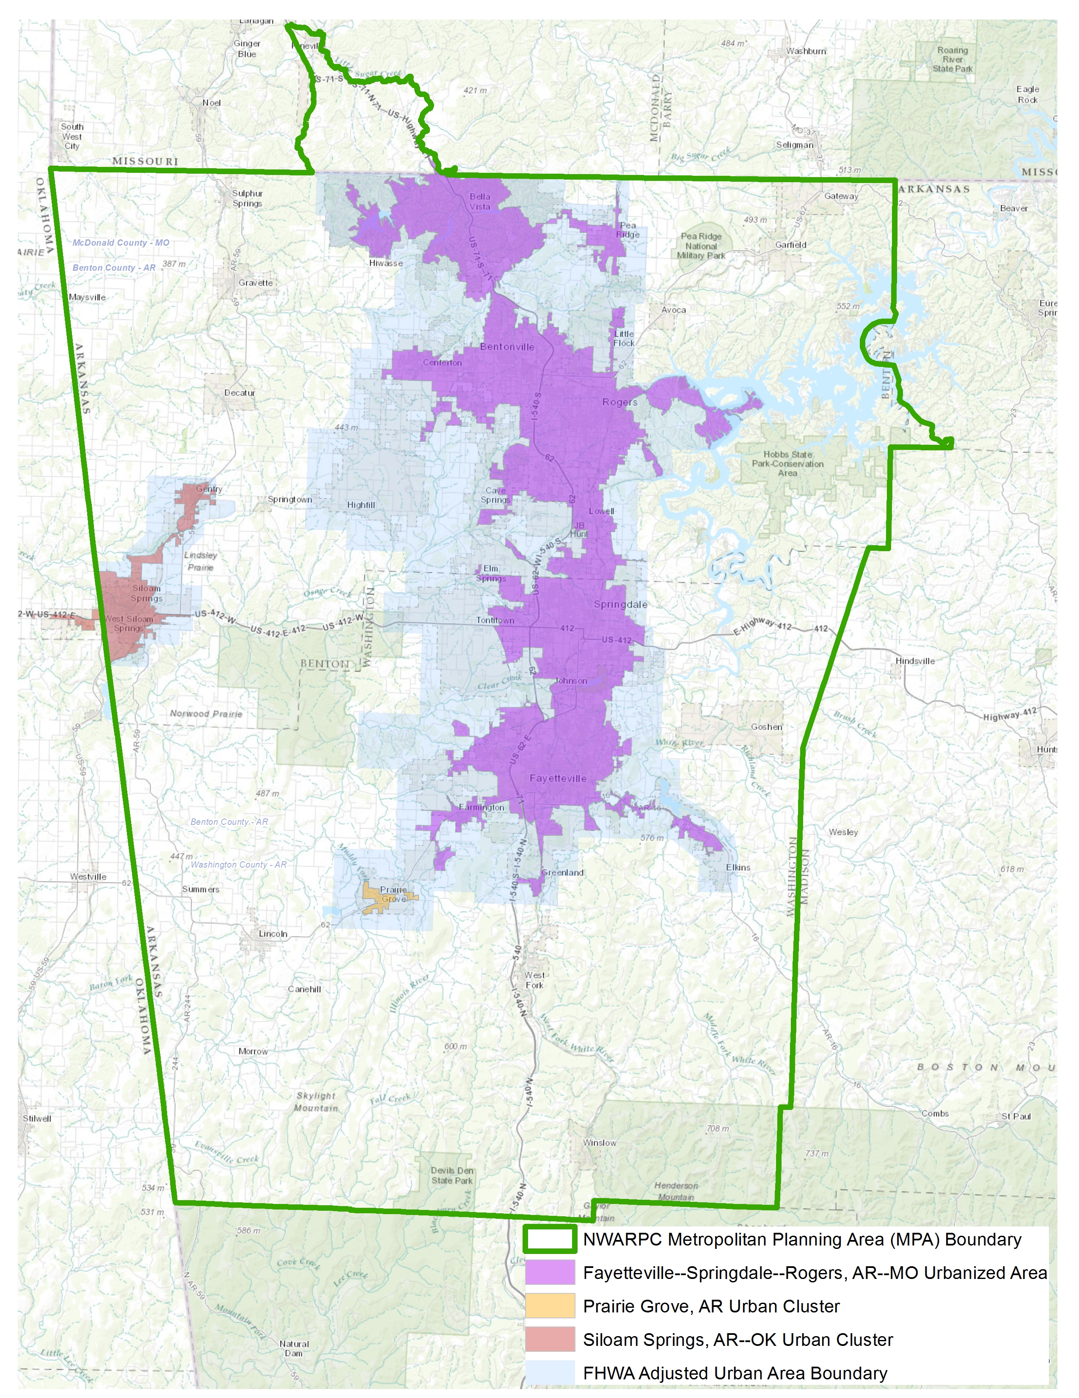
NARTS METROPOLITAN PLANNING AREA

FAST ACT FACTORS CONSIDERED BY PROGRAM ELEMENT

On December 4, 2015, the President signed the Fixing America’s Surface Transportation (FAST) Act into law (P.L. 114-94).

Section 134 of Title 23, U.S.C. reads:
(a) Policy. – It is in the national interest –
“(1) to encourage and promote the safe and efficient management, operation, and development of surface transportation systems that will serve the mobility needs of people and freight and foster economic growth and development within and between States and urbanized areas, while minimizing transportation-related fuel consumption and air pollution through metropolitan and statewide transportation planning processes identified in this chapter; and
(2) to encourage the continued improvement and evolution of the metropolitan and statewide transportation planning processes by metropolitan planning organizations, State departments of transportation, and public transit operators as guided by the planning factors identified in subsection (h) and section 135(d).”

(f) Coordination in Multistate Areas.—
(1) In general.—The Secretary shall encourage each Governor with responsibility for a portion of a multistate metropolitan area and the appropriate metropolitan planning organizations to provide coordinated transportation planning for the entire metropolitan area.
(2) Interstate compacts.—The consent of Congress is granted to any two or more States—
(A) to enter into agreements or compacts, not in conflict with any law of the United States, for cooperative efforts and mutual assistance in support of activities authorized under this section as the activities pertain to interstate areas and localities within the States; and
(B) to establish such agencies, joint or otherwise, as the States may determine desirable for making the agreements and compacts effective.

PLANNING FACTORS
(h) Scope of Planning Process.—
(1) In general.—The metropolitan planning process for a metropolitan planning area under this section shall provide for consideration of projects and strategies that will—
(A) Support the economic vitality of the metropolitan area, especially by enabling global competitiveness, productivity, and efficiency;
(B) Increase the safety of the transportation system for motorized and non-motorized users;
(C) Increase the security of the transportation system for motorized and non-motorized users;
(D) Increase the accessibility and mobility of people and for freight;
(E) Protect and enhance the environment, promote energy conservation, improve the quality of life, and promote consistency between transportation improvements and State and local planned growth and economic development patterns;
(F) Enhance the integration and connectivity of the transportation system, across and between modes, for people and freight;
(G) Promote efficient system management and operation; and
(H) Emphasize the preservation of the existing transportation system.
The FAST Act inserted two additional factors:
(I) Improve the resiliency and reliability of the transportation system and reduce or mitigate stormwater
impacts of surface transportation; and
(J) Enhance travel and tourism.

The Planning Factors, which apply to each Element of the Unified Planning Work Program, are listed in the table below.
FAST ACT PLANNING FACTORS | A | B | C | D | E | F | G | H | I | J
44.21: Program Support and Administration |  |  |  |  | X |  |  | X
44.22: General Development and Comprehensive Planning | X |  |  | X | X | X | X | X
44.23: Long-Range Transportation Planning | X | X | X | X | X | X | X | X | X | X
44.24: Short-Range Transportation Planning | X | X | X | X | X | X | X | X | X
44.25: Transportation Improvement Program | X | X | X | X | X | X | X | X | X | X

44.21: PROGRAM SUPPORT AND ADMINISTRATION

WORK TASKS

- Provide those administrative, budgeting, bookkeeping, and clerical duties required in order to perform work tasks and comply with AHTD, MoDOT, FHWA, and FTA requirements. Progress reports and related documentation will be prepared in conjunction with PL activities, as well as the FY 2018 Unified Planning Work Program.

- Improve office equipment, computer systems, and software as needed to keep pace with state-of-the-art technology currently in use for improved communications, mapping, planning analysis and report production. Train staff on software packages. (The cost of equipment and software will be shared proportionately by all elements.)

- Attend planning, transportation, and transit meetings; attend training, workshops and conferences to maintain coordination with other agencies, staff proficiency and professional improvement. Keep informed of AHTD, MoDOT, FHWA, and FTA programs, as well as local issues and trends in order to provide proper assistance to local governments and agencies. Information bulletins and correspondence will be reviewed. Necessary AHTD, MoDOT, AMPO, TRB meetings and conferences will be attended.

- NWARPC will continue public involvement procedures for all aspects of transportation planning as specified in the NARTS Public Participation Plan (PPP). The PPP and procedures will be reviewed and changed if needed to reflect changes in NARTS Bylaws, FAST Act provisions, or other transportation-related legislation.

- NWARPC will comply with Title II of the Americans with Disabilities Act, Section 504 of the Rehabilitation Act, and Title VI of the Civil Rights Act. Staff will revisit and review plan documents as needed. The Civil Rights coordinator will offer Title VI training in July 2016.

- Staff will work with Missouri Department of Transportation (MoDOT) staff and partners to provide coordinated transportation planning for the entire metropolitan area and establish all needed agreements, maps, documents, and procedures for cooperative efforts and mutual assistance in support of activities related to Missouri’s inclusion in the Fayetteville-Springdale-Rogers, AR-MO Urbanized Area.

 | END PRODUCTS | COMPLETION DATES
A1. | Record keeping, daily correspondence and Progress Reports | Monthly/On-going
A2. | Audit Report and Performance Report | On-going
A3. | Committee meetings and planning process coordination | On-going
A4. | FY 2018 UPWP | May 2017
B. | Computer and software upgrades | On-going
C. | Meeting attendance | On-going
D. | Documentation of PPP compliance will be kept on file | On-going
E. | Section 504/ADA Self Evaluation/Title VI Program Plan staff training | On-going
F. | Coordination with MoDOT | On-going
COOPERATING AGENCIES: NWARPC, MoDOT, AHTD, FHWA and FTA.

COST DATA
Federal $140,459
Local (MPO) $ 35,115
Total $175,574
Element Percent 22.26%

44.22: GENERAL DEVELOPMENT AND COMPREHENSIVE PLANNING

WORK TASKS

A. Staff will maintain files that indicate demographic and infrastructure data within the NARTS Area. Census data and other information will be utilized and incorporated into reports, thematic maps, and TAZ boundaries. These data will be utilized to develop the demographics of the forecast years for the Travel Demand Model. Collection and reporting of regional data from units of government will continue. Staff will assist cities as needed for Census boundary updates.

B. Staff will obtain the most current traffic count data at locations collected by AHTD and MoDOT.

C. Staff will evaluate the available crash rate data within the metropolitan planning area. Staff will coordinate with AHTD and MoDOT on the use of the data to meet FAST Act performance measures, AHTD and MoDOT performance targets, and future MPO performance measures for the region to reduce traffic fatalities and serious injuries on public roads.

D. Staff will evaluate transit data within the metropolitan planning area. Staff will coordinate with Ozark Regional Transit and Razorback Transit on the use of the data to meet FAST Act performance targets, and future MPO performance measures for the region. The travel demand model will be utilized for scenario testing and model runs in support of the two agencies planning efforts.

 | END PRODUCTS | COMPLETION DATES
A. | Demographic and infrastructure data for the region will be utilized for transportation planning, forecasting, and analysis. | On-going
B. | Traffic data files showing most recent traffic counts and changes relative to previous counts will be maintained in cooperation with AHTD and MoDOT. | On-going
C. | Collection and analysis of data on performance targets in coordination with AHTD and MoDOT. | On-going
D. | Collection and analysis of data on performance targets and measures in coordination with Ozark Regional Transit and Razorback Transit. | On-going

COOPERATING AGENCIES: NWARPC, AHTD, MoDOT, Transit Agencies, Arkansas State Data Center, local governments.

PL COST DATA
Federal $ 120,000
Local (MPO) $ 30,000
Total $ 150,000
Element Percent 19.02%

ADDITIONAL COST DATA
Federal Local (MPO) Total
MO PL Funds $ 2,500 $ 625 $ 3,125
STBGP-A Funds $ 70,000 $ 17,500 $87,500
FTA 5307 Funds $ 20,000 $ 5,000 $25,000

Note: Up to $15,000 of 5307 funds may be spent for technical support for the NWA Travel Demand Model.

44.23: LONG-RANGE TRANSPORTATION PLANNING

WORK TASKS

- ASSISTANCE TO PARTICIPATING JURISDICTIONS:
  - Work with the local jurisdictions to further define project priorities and explore funding options.

B. TRAVEL DEMAND MODELING:
  - Work with AHTD in utilizing the forecasts for the Travel Demand Model.
  - Train staff on maintenance and use of the Travel Demand Model.
  - Utilize the Travel Demand Model to refine and prioritize the regional arterial network.
  - Assist cities with Travel Demand Model scenarios.
  - Utilize the Travel Demand Model to assist both transit agencies with route optimization and scenario planning and development.
  - Utilize the Travel Demand Model for the Congestion Management Process.
  - Utilize the Travel Demand Model to support development of a performance-based approach to transportation decision-making.
  - Implement priority phases of the “blueprint” for the Travel Demand Model enhancement.
C. BICYCLE AND PEDESTRIAN
1. Continue the development and implementation of the NWA Regional Bicycle and Pedestrian Master Plan (adopted as part of the 2040 MTP, March 2016) that will enhance the full connectivity of non-motorized transportation throughout Northwest Arkansas and provide for a well-planned, safe and efficient system for pedestrians and bicyclists that will connect local jurisdictions and destinations such as employment, shopping, health and education centers.
- The goals of the Master Plan will be shared with the general public, cities, and consultants.
- Continue evaluation of the region’s topography and natural environment, including greenway corridors, for logical locations and connections.
- Encourage and support implementation of the individual plans and assist the cities as needed to meet the goal of implementing aspects of the 5E’s: engineering, education, encouragement, enforcement, and evaluation.
- Continue evaluation of individual jurisdictions’ bicycle and pedestrian plans for connectivity to the regional system.
- Include the Missouri portion of the MPA in the development of a regional bicycle and pedestrian system.
2. Performance Measures and Measurable Goals
- NWARPC will work with AHTD, MoDOT and local jurisdictions to identify measures and to develop methodologies to implement performance-based planning and programming for alternative transportation.
3. Continue to support the NWA Heritage Trail Plan.
- Staff will offer informational assistance to citizen groups formed to promote the Heritage Trail and the full regional bicycle and pedestrian system plan.
- Efforts will be made to promote proper signage for the Heritage Trail and the broader system.
- Additions to the Heritage Trail Plan will be evaluated.
4. Staff will offer assistance to local jurisdictions in updating and implementing their respective bicycle and pedestrian plans.

- 2040 NWA METROPOLITAN TRANSPORTATION PLAN (MTP)
1. The NWARPC/Policy Committee adopted the 2040 NWA Metropolitan Transportation Plan on March 23, 2016.
2. All amendments to the MTP will be conducted according to the Public Participation Plan and written notice of all such amendments will be made to State and Federal officials.
3. Continue to monitor Performance Measures and Targets as identified in the MTP.
- Surface Transportation Targets
- Public Transit Performance Targets
- Integration of other Performance-Based Plans (AHTD and MoDOT)
- Amend the MTP, as necessary, to include a description of the performance measures and performance targets used in assessing the performance of the transportation system.
4. Staff will assist AHTD with the following studies:
- Highway 16 from Highway 265 to Elkins
- Highway 71 in Bella Vista
- Various interchanges along I-49
- Highway 72 from I-49 to Pea Ridge
- Highway 412 from Highway 112 to East of I-49 (Springdale)
- Highway 71B from Highway 412 to Highway 264 (Springdale and Rogers)
- Highway 102 from Highway 102B to Highway 94 (Centerton, Bentonville, and Rogers)
- Highway 59 from Highway 72 West to Highway 72 East (Gravette)
- Highway 94 from Highway 71B to Old Wire Road (Rogers).

E. CONTINUE ACTIVITIES TO ADVANCE THE FOLLOWING, THROUGH NWARPC/POLICY COMMITTEE, TAC, AND OTHER SUBCOMMITTEES:
1. NWA Regional Bicycle and Pedestrian Master Plan, Individual Community Plans and Heritage Trail Plan
2. Congestion Management Process
3. MTP Implementation
4. Community Involvement
5. Transit Development Plan
6. Utilization of STBGP-A and TAP funds
7. Performance Measures and Targets
8. Safety Planning Needs

F. ITS REGIONAL ARCHITECTURE and DEPLOYMENT PLANNING (ITS PLAN):
1. The ITS Plan was updated through the 2040 NWA MTP process.
2. The Management and Operations Committee will meet quarterly to further ITS Plan Recommendations.
3. Work with AHTD, MoDOT and local governments to coordinate and facilitate ITS deployment projects that meet the criteria of the adopted ITS Regional Architecture.

G. FIXING AMERICA’S SURFACE TRANSPORTATION (FAST) ACT COMPLIANCE:
1. The FAST Act was signed into law on December 4, 2015.
2. The 2040 NWA MTP update began under MAP-21 and was adopted under FAST Act. To the extent possible, the MTP was written to incorporate MAP-21 and FAST Act requirements. The MTP will be amended, as necessary, to incorporate FAST Act requirements.

 | END PRODUCTS | COMPLETION DATES
A. | NARTS participation | On-going
B. | Utilize TDM to assist transit agencies with route optimization and scenario planning and assist jurisdictions | On-going
C. | Performance Measures and Measurable Goals | On-going
D. | 2040 MTP Implementation and Updates | On-going
E. | NARTS participation through NWARPC/Policy Committee, TAC, other committees | On-going
F. | NARTS participation toward ITS deployment projects | On-going
G. | 2040 MTP compliance with FAST Act | On-going
COOPERATING AGENCIES: NWARPC, AHTD, MoDOT, Razorback Transit, Ozark Regional Transit, Inc.,
Northwest Arkansas Regional Airport Authority, NWA Regional Mobility Authority, and local governments.

PL COST DATA
Federal $165,526
Local (MPO) $ 41,382
Total $206,908
Element Percent 26.23%

ADDITIONAL COST DATA
Federal Local (MPO) Total
STBGP-A Funds $20,000 $5,000 $25,000

Note: Up to $15,000 of PL funds may be spent for support and maintenance of the TransCad software and technical support for the NWA Travel Demand Model.

44.24: SHORT-RANGE TRANSPORTATION PLANNING

WORK TASKS

- STAFF WILL ASSIST COUNTIES, CITIES, CITIZENS, AND THE MEDIA IN UNDERSTANDING THE PROCESS OF MPO TRANSPORTATION PLANNING AND THE IMPACT OF TRANSPORTATION PROJECTS BOTH SHORT TERM AND LONG TERM:
1. Staff will update, as necessary, a brochure and web site outlining transportation planning procedures for the NARTS Technical Advisory Committee (TAC) and the NWARPC/Policy Committee, and the general public. This brochure and web site will detail how regional plans are implemented and who to contact for questions and answers.
2. Staff will work with cities to create an understanding of the work and role of the MPO.
3. Staff will attend transportation planning sessions hosted by AHTD, MoDOT, cities, other agencies, and professional organizations.

- INTER-GOVERNMENTAL REVIEW PROCESS:
1. Review area FTA and FHWA funding applications.

- OZARK REGIONAL TRANSIT, INC:
1. Staff will continue to support and assist ORT in their activities.
2. Recommend ORT conduct a Public Relations Campaign / Rebrand Ozark Regional Transit.
3. Recommend ORT continue and expand route testing with NWA businesses and municipalities.

- RAZORBACK TRANSIT:
1. Staff will continue support and assist Razorback Transit in their activities.

E. TRANSIT DEVELOPMENT PLAN/TRANSIT ORIENTED DEVELOPMENT:
1. Update the 2011 transit development plan for the region. The transit development plan should include both ORT and Razorback Transit.
2. Establish region-wide transit oriented development (TOD) best practices.

F. TRANSIT PERFORMANCE MEASURES:
- Staff will monitor and review transit performance measures rule-making.
- Staff will assist local transit agencies in the development of performance targets for the region.
- Staff will coordinate transit performance measures with AHTD.
4. Staff will coordinate with AHTD to develop and utilize performance measures and analytical methods to measure the transportation system’s connectivity to essential services.

G. STATEWIDE PUBLIC TRANSPORTATION COORDINATION PLAN:
1. Staff will continue to monitor the Statewide Plan and assist public transit operators and human services providers in coordinating the delivery of transit services.

H. MAPPING/GIS: Provide mapping and GIS assistance to participating units and maintain county and regional maps. Coordinate regional GIS efforts in three primary types of data and information:
1. Vector files (roads, county boundary, annexations, contours, etc.).
2. Raster files (aerial imagery).
3. File sharing and workflow strategies.

I. PLANNING ASSISTANCE: Staff will assist counties and cities, as well as the Northwest Arkansas Regional Mobility Authority, in utilizing transportation resources by disseminating information regarding transportation programs. Staff will also assist counties and cities regarding transportation planning, updating Master Street plans, and utilization of the Travel Demand Model.

J. Congestion Management Process:
1. Staff will continue to develop the Congestion Management Process for the region.
2. The Management and Operations Committee will utilize data sources and software to monitor and perform analysis on the CMP network.

K. PERFORMANCE-BASED APPROACH – METROPOLITAN TRANSPORTATION PLANNING:
1. FAST Act continues MAP-21 requirements for the MPO to establish and use a “performance-based approach to transportation decision making” that supports FAST Act National Goals. The MPO will continue to coordinate with AHTD and MoDOT on the establishment of a “performance based approach” to transportation planning and the establishment of MPO “performance measures and performance targets” that will be integrated into the 2040 Northwest Arkansas Metropolitan Transportation Plan and the NWARPC FFY 2016 -2020 Transportation Improvement Program.

2040 Metropolitan Transportation Plan - Framework - National, State, and Region
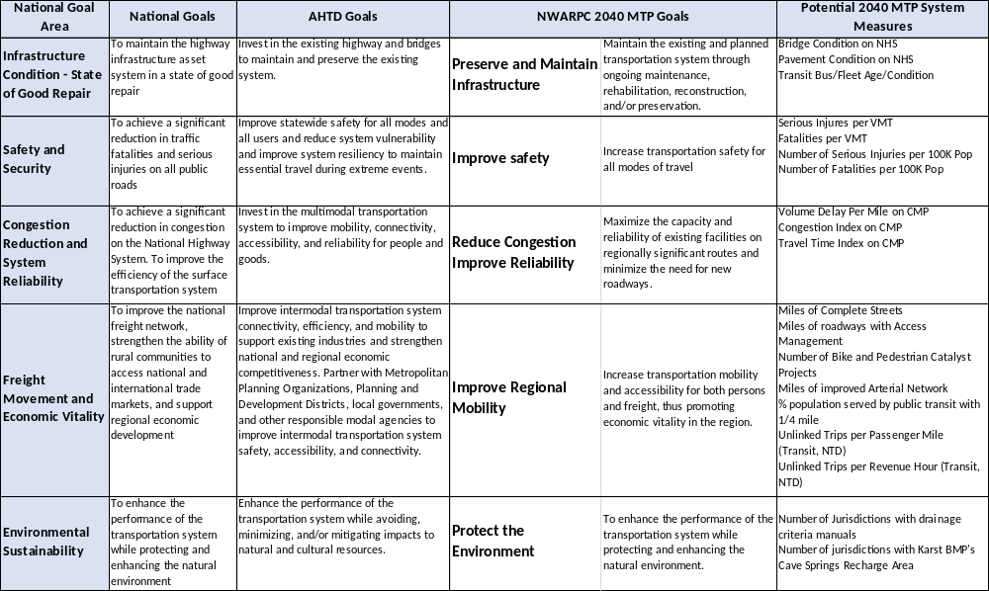

* Potential Performance Measures based on FHWA Notice of Proposed Rule Making (NPRM) and also includes on-going NWARPC initiatives and implementation of plans.

 | END PRODUCTS | COMPLETION DATES
A. | Shared Information: NWARPC website, and other pertinent data, news releases, relevant technology transfer information and informational brochure. | On-going
B. | Application Reviews | On-going
C. | NARTS participation | On-going
D. | NARTS participation | On-going
E. | NARTS participation/Transit Dev. Plan/Establish TOD Best Practices | June 2017/On-going
F. | NARTS participation | On-going
G. | Coordination with AHTD | On-going
H. | Maps and digital data sets | On-going
I. | Informational memos and assistance | On-going
J. | Congestion Management Process | On-going
K. | Performance-based approach | On-going
COOPERATING AGENCIES: NWARPC, MoDOT, AHTD, FHWA, FTA, various state and federal agencies, NWA Regional Mobility Authority, Ozark Regional Transit, Inc., Razorback Transit, area human service agencies and local jurisdictions.

PL COST DATA
Federal $165,000
Local (MPO) $ 41,250
Total $206,250
Element Percent 26.15%

ADDITIONAL COST DATA
Federal Local (MPO) Total
MO PL Funds $ 2,500 $ 625 $ 3,125
STBGP-A Funds $60,000 $15,000 $ 75,000
FTA 5307 Funds $80,000 $20,000 $100,000

Note: FTA 5307 funds will be utilized to update the Transit Development Plan.

44.25: TRANSPORTATION IMPROVEMENT PROGRAM

WORK TASKS

A. The FFY 2016-2020 TIP, developed in conjunction with AHTD, MoDOT and local authorities, was adopted March 23, 2016 and will be amended as needed. Yearly TIP updates will coincide with AHTD and MoDOT STIP updates.
B. Staff will assist TAC, NWARPC/Policy Committee and individual jurisdictions in the development and implementation of policies and procedures regarding the selection of projects through a competitive process, and the utilization of Surface Transportation Block Grant Program-Attributable (STBGP-A) and Transportation Alternatives Program (TAP) funds.
C. The Annual Listing of Projects (ALOP) for which federal highway and transit funds have been obligated will be published. The Annual Listing of Projects is published on the NWARPC website every December.

 | END PRODUCTS | COMPLETION
A. | FFY 2016-2020 TIP and amendments and yearly update | On-going
B. | STBGP-A and TAP Procedures and Polices | On-going
C. | Published Annual Listing of Projects | December 2016
COOPERATING AGENCIES: NWARPC, AHTD, MoDOT, FHWA, FTA, Razorback Transit, Ozark Regional Transit, Inc., and local governments.

PL COST DATA
Federal $40,000
Local (MPO) $10,000
Total $50,000
Element Percent 6.34%

ADDITIONAL COST DATA
Federal Local (MPO) Total
STBGP-A Funds $50,000 $12,500 $62,500

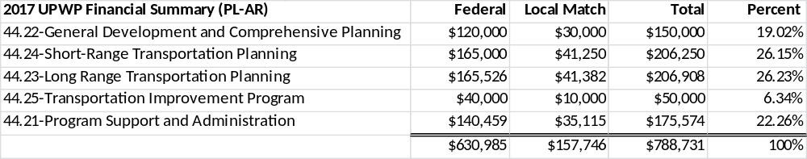

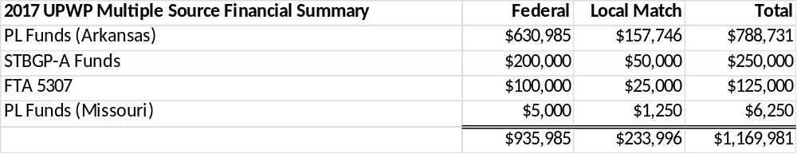

NOTES:
- Confirmed FY 2015 PL carry-over funds may be added to the FY 2017 UPWP PL funds.
- Missouri PL funds in the amount of $5,000 with a $1,250 local match will be added to Element 100 and 200 to support Missouri-based planning activities.
- FFY 2015 STP-A carry-over funds and FFY 2016 STBGP-A funding will be utilized in the FFY 2017 UPWP.
- All references to PL funds in this document relate to Arkansas PL funds unless noted to be Missouri funds.

ADOPTION:
This Unified Planning Work Program (UPWP) was prepared as a part of the Northwest Arkansas Regional Transportation Study (NARTS). Public notice concerning this Program was published in The Northwest Arkansas Democrat-Gazette newspaper and the La Prensa Libra newspaper on April 14, 2016 and May 12, 2016. A Public Comment period was held from April 22 through May 6, 2016. The Technical Advisory Committee recommended the Program for adoption on May 19, 2016. The NWARPC/Policy Committee reviewed and adopted the Program on May 25, 2016.

I hereby certify the adoption of this UPWP for State Fiscal Year 2017 by the NWARPC/Policy Committee on this 25TH day of May 2016.



